APPENDIX FOUR

CAMPUS MAP

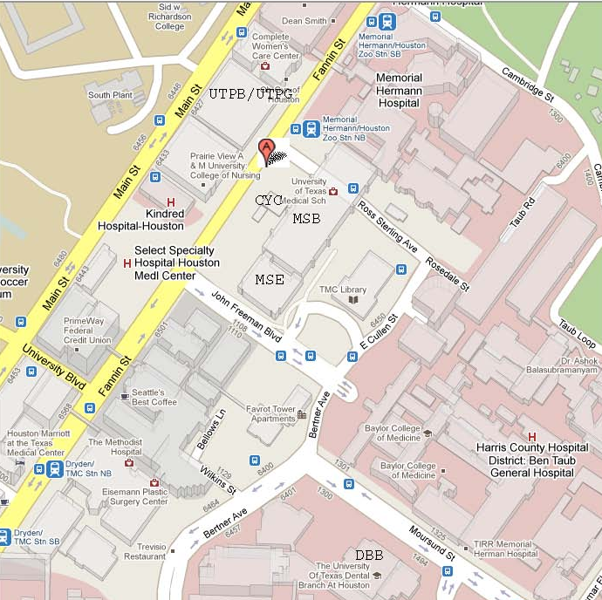

Facility locations in this image:
MSB – Medical School Building

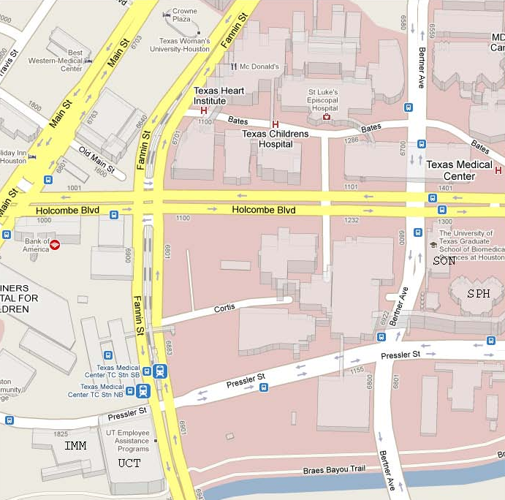

Facility locations in this image:
SON – School of Nursing

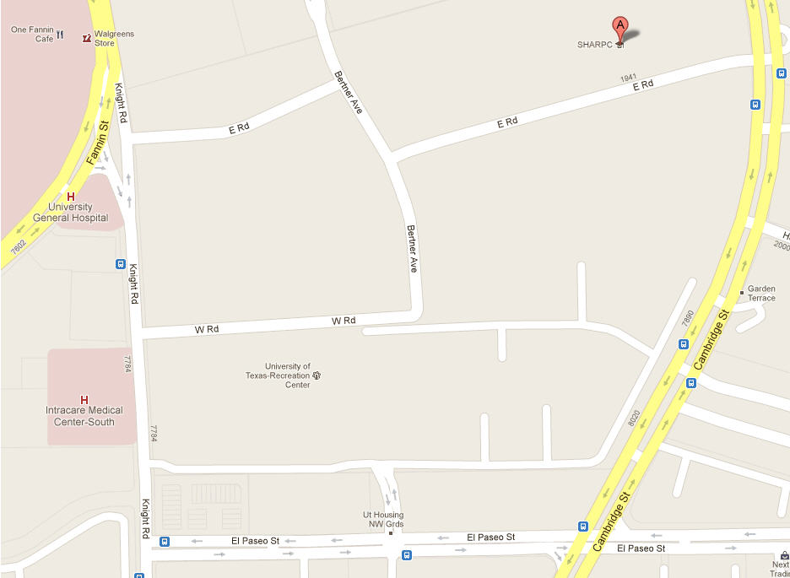
STUDENT / FACULTY HOUSING
AUX / REC
SOD
BBS

Facility locations in this image:
SOD – School of Dentistry

